**Different concepts of python programming language**

def printEmpSkill(name,*skillset):

print('{0} is skilled in {1} language'.format(name,skillset))

print('{0} is skilled in {1} language'.format(name,len(skillset)))

return None

printEmpSkill('Alex','Python','html')

printEmpSkill('Pravesh','Java','C','C++')

printEmpSkill('Ajay')

**OUTPUT**

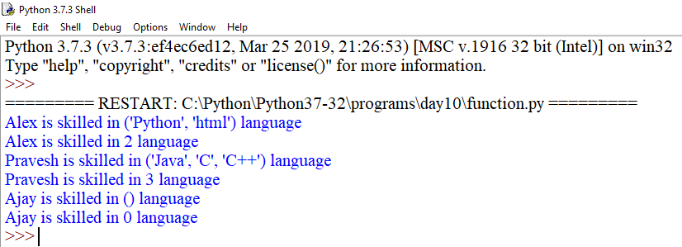

class A:

pass

class B:

pass

class Employee(A,B):

empCount=0

def __init__(self,name,salary):

self.name=name

self.salary=salary

Employee.empCount+=1

def displayCount(self):

print("Total Employee %d" % Employee.empCount)

def displayEmployee(self):

print("Name :",self.name,"Salary :",self.salary)

if __name__=="__main__":

print("Employee.__doc__:",Employee.__doc__)

print("Employee.__name__:",Employee.__name__)

print("Employee.__module__:",Employee.__module__)

print("Employee.__bases__:",Employee.__bases__)

print("Employee.__dict__:",Employee.__dict__)

**OUTPUT**

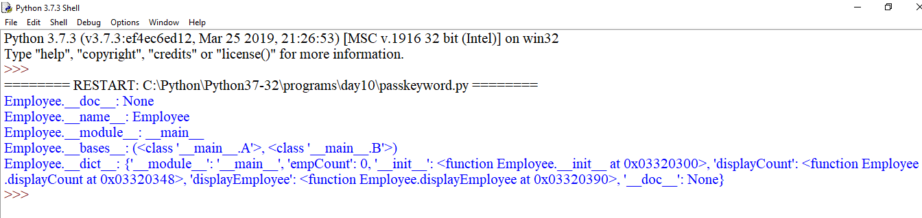

def test_fun(stream,course,fees):

print("arg1:",stream)

print("arg2:",course)

print("arg3:",fees)

return

tup1=('Programming','python',20000)

test_fun(*tup1)

dict1={"fees":30000,"course":"Animation","stream":"multimedia"}

test_fun(**dict1)

**OUTPUT**

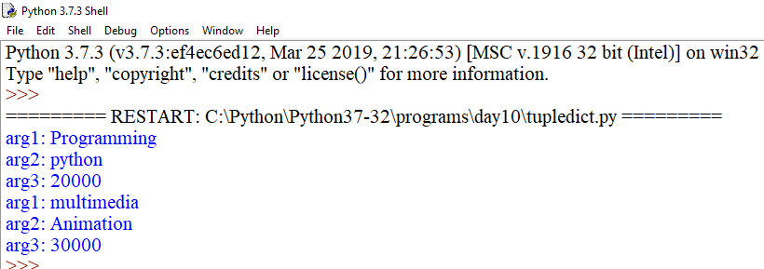

def printinfo(arg1,*vartuple):

print("Output is:",arg1)

print("Contents of variable length tupe is:")

for var_temp in vartuple:

print(var_temp,end=" ")

print()

return

if __name__=="__main__":

printinfo(10)

printinfo(70,60,50)

printinfo(70,60,'tea','samosa','chips','cake',50)

**OUTPUT**

